Date:

# EXPERIMENT NO. 2

#### AIM: Implement a circuit in Logisim which perform Addition and Subtraction of sign

#### number.

**ALGORITHM:**

**CIRCUITS:**

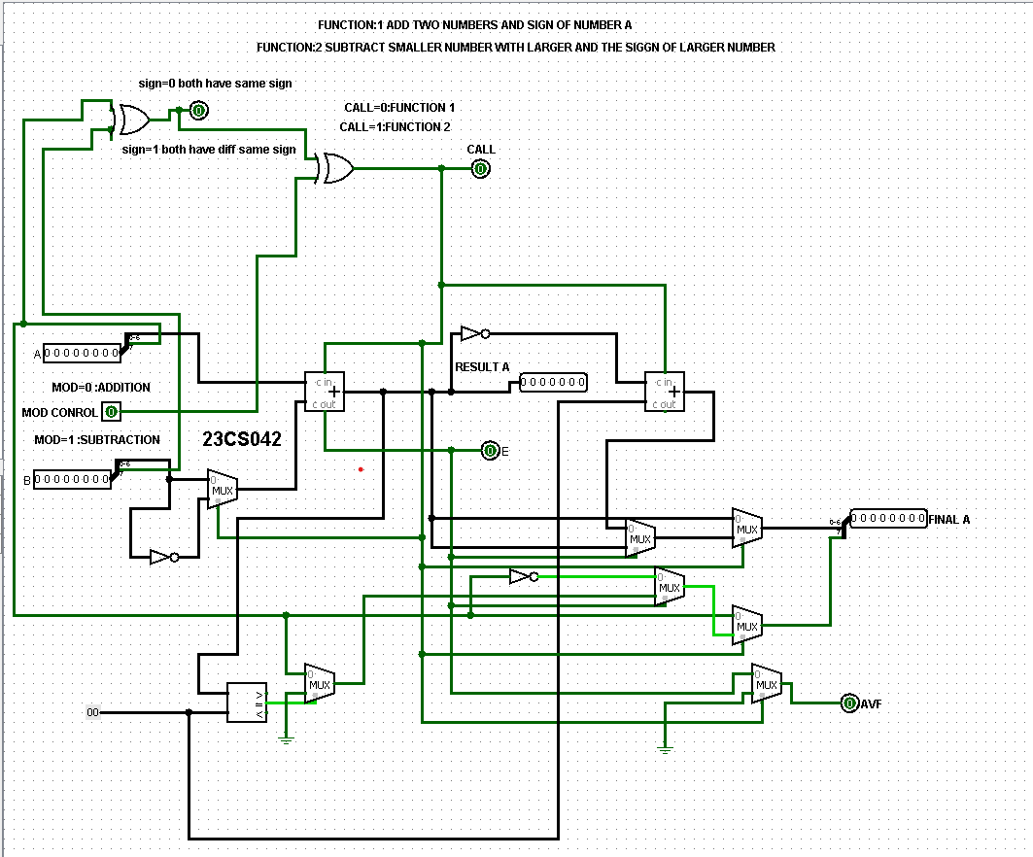

**OUTPUTS:**

**(+42)+(+55)=(+97) {(00101010)+(00110111)=(01100001)}**

**(-42)+(-55)=(+97) {(00101010)+(00110111)=(11100001)}**

**(+42)+(-55)=(-11) {(00101010)+(10110111)=(10001101)}**

**(-42)+(+55)=(+11) {(00101010)+(10110111)=(00001101)}**

**(+42)-(+55)=(-11) {(00101010)+(10110111)=(10001101)}**

**(-42)-(-55)=(+11) {(00101010)+(10110111)=(00001101)}**

**(+42)-(-55)=(+97) {(00101010)+(00110111)=(01100001)}**

**(-42)-(+55)=(-97) {(00101010)+(00110111)=(11100001)}**

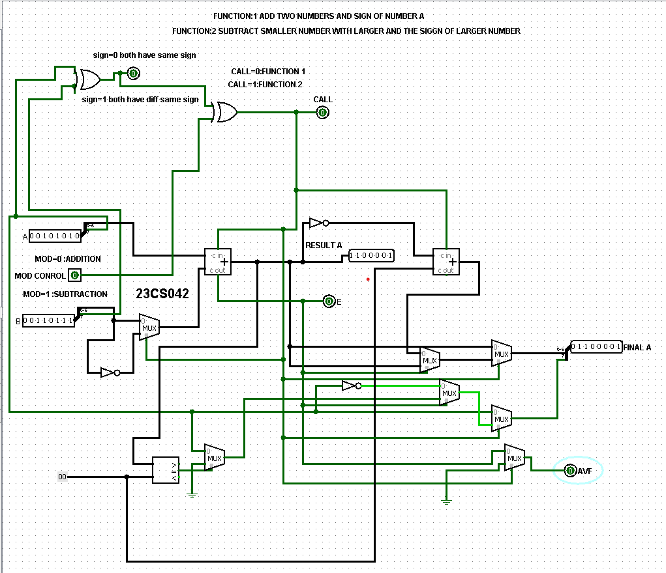

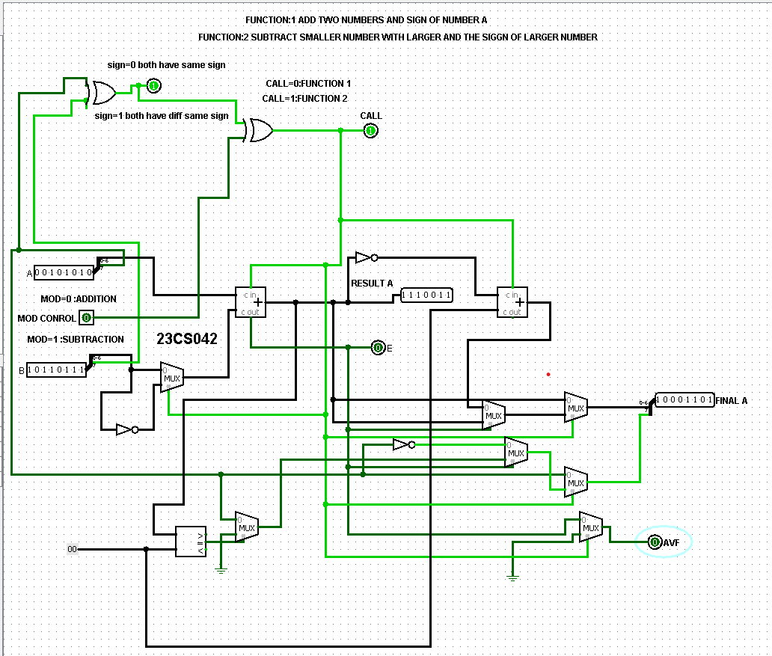

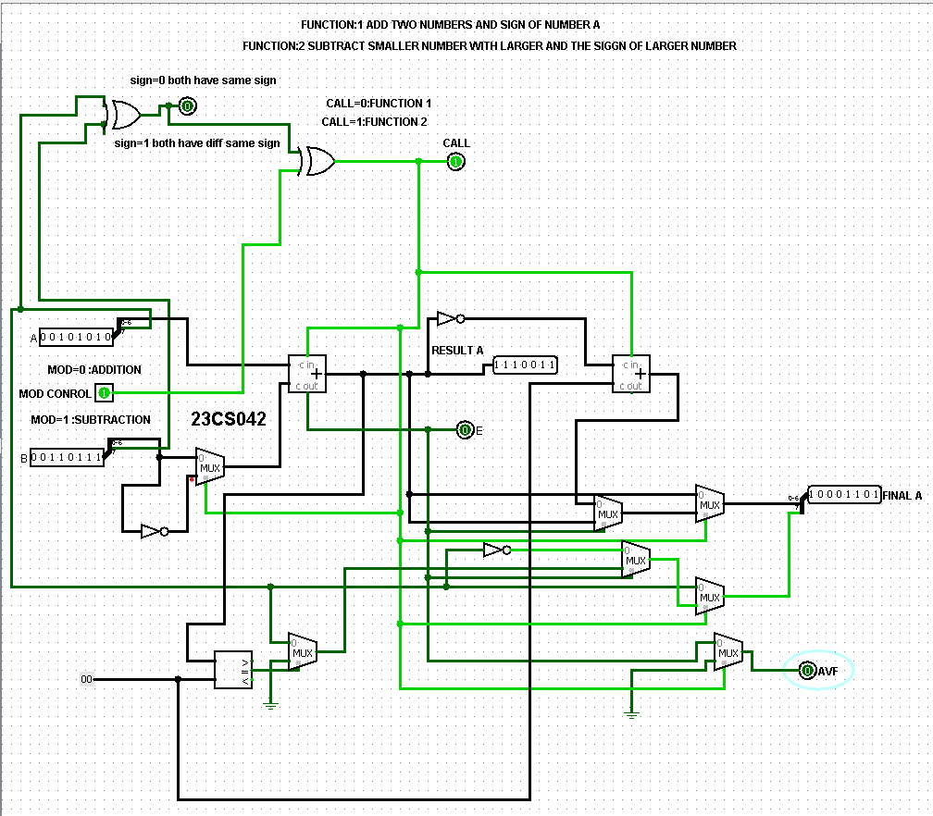

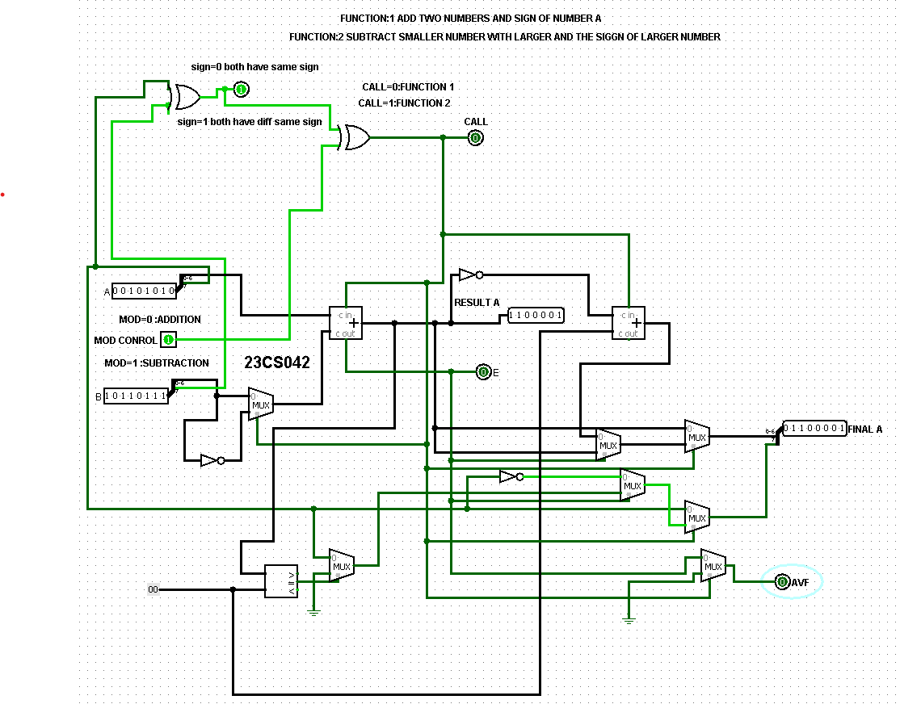

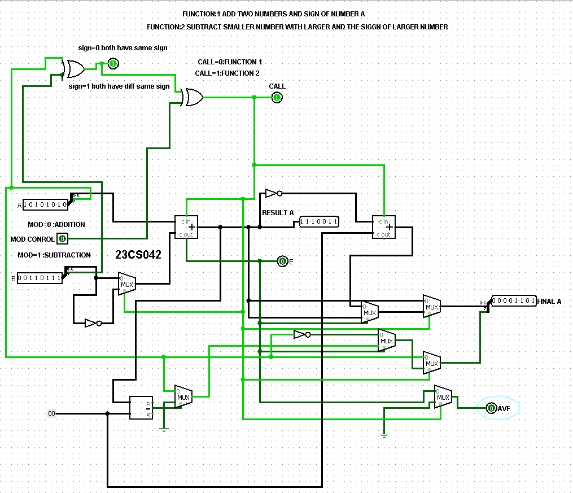

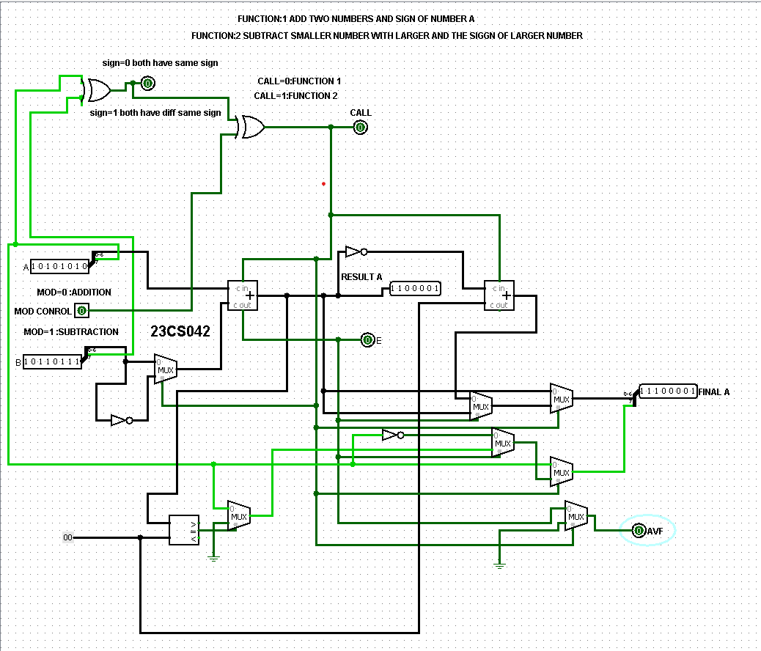

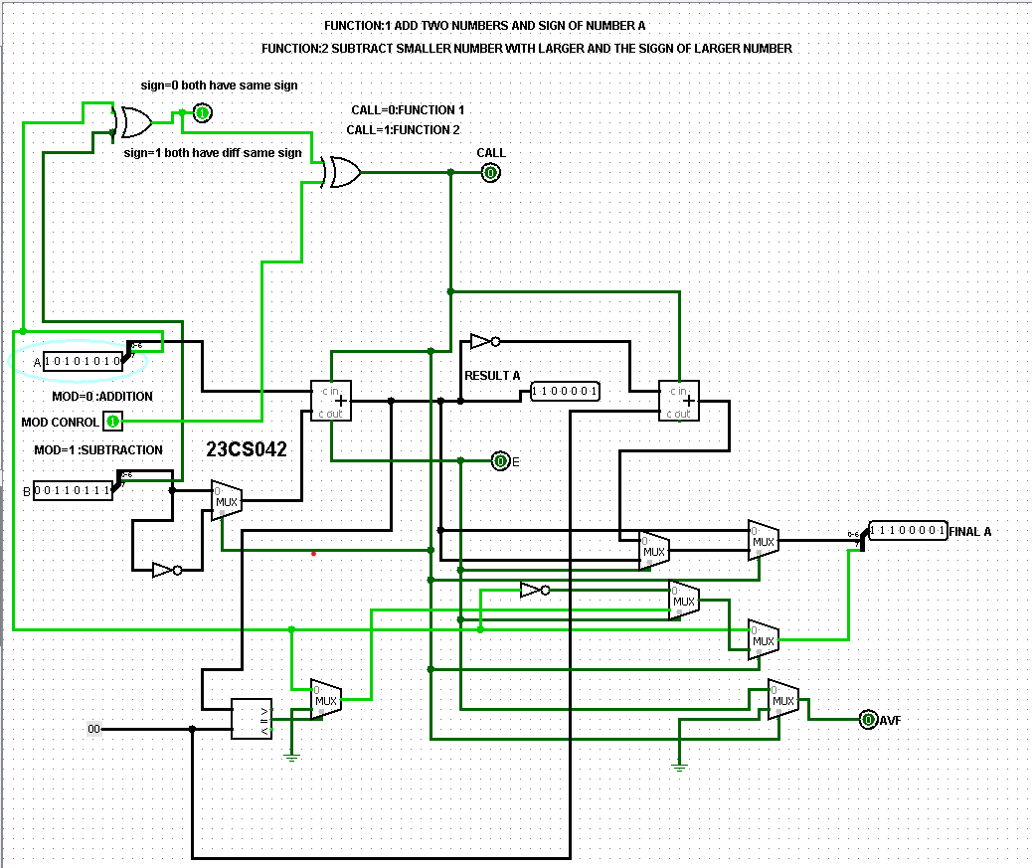

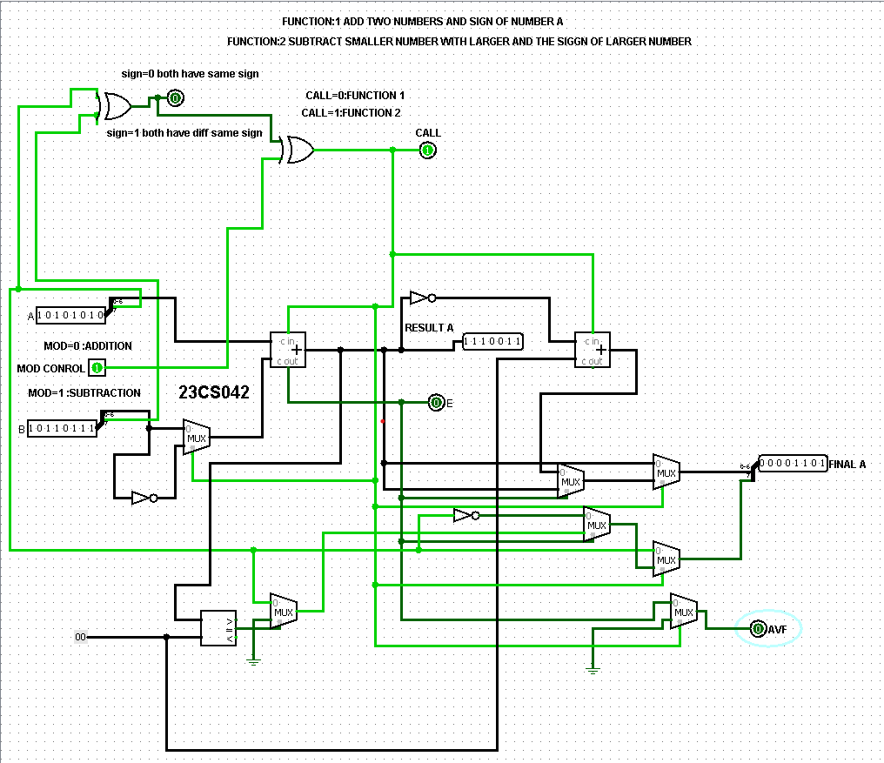

**CONCLUSION:**